**An English Class That Spans Two Continents**

Published on May 27, 2019 08:14:11 *“China Insurance Journal”*

*Special correspondent LI Jinwei photographic Report*

‘Hello, everyone! Today we will talk about food from all over the world. First of all, let's review some vocabulary, then we will move on to show you some food from different countries and some videos.’

It was 8:30 am, May 16. An online third-grade oral English lecture delivered by student volunteers from Lakefield College School, a Canadian high school, was taking place at Xudatun Primary School, a Chinese school located at the rural area north of Dalian City. Three Canadian teachers, Nicole, Liam and Berhan, were coaching pupils who came from remote countryside of China in English vocabularies through slides. The pupils were following the foreign teachers, despite with a little dialect, very carefully lest they should miss any word.

‘Children in remote rural areas know that such learning opportunities are rare and that this may be their hope to get rid of their family difficulties in the future.’ Wang kuili, general manager of Taiping Pension’s Dalian branch, told China Insurance News.

The online lecture, which lasted for around one hour, was over soon. Our reporter was then invited to have a transoceanic video call with the Canadian teachers.

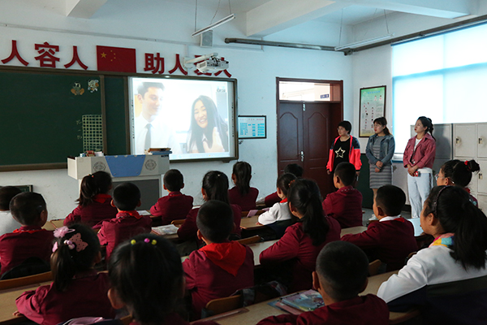

‘Hello Nicole, Liam and Burhan! Thank you for joining hands with volunteers from Taiping Pension to build an online English classroom for those Chinese rural children. While you are taking part in the meaningful work of poverty alleviation in China, you are also building a bridge of friendship between Chinese and Canadian children.’

‘We participate in this program to help these poor children improve their English listening and speaking skills. We focus on teaching them simple conversations in English and increase their interest in learning English." said Nicole. ‘If they would like to go into service industry or start a business in the future, proficiency in English can help them move to a higher platform.’

Liam then said, "what I like about this project is that it allows me to get to know and communicate with children in remote rural areas of China. Although we are so far apart, it seems that our hearts are very close. During the conversation, I feel that they are sitting in front of me, crossing the space and I feel very warm."

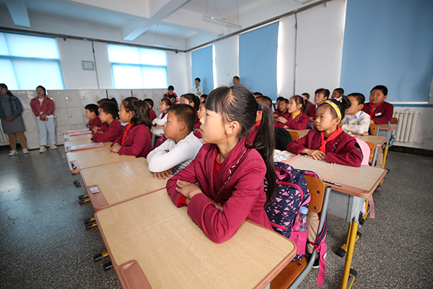

There is only one class in the third grade of Xudatun Primary School with 29 students in total, among which single parent families, poor families and disabled students account for 30%. In 2018, Taiping Pension carried out a poverty alleviation survey in Xudatun Village. After learning about the special student group, it had focused its poverty alleviation work on education aid. Taiping Pension then conducted one-to-one donation for those poor pupils, covering their school bus fee and safety insurance.

In 2018, knowing that a charitable organization called C² from Lakefield College School, Canada, had been insisting on delivering online English lectures to Shigui Elementary School, a rural school located at a mountainous area of Nanchong, Sichuan Province, Taiping Pension got into contact with the non-profit group immediately, asking for giving lectures to poor pupils from Xudatun Primary School. They soon received positive response, and the courses successfully started in March 2019. In order to ensure the learning effect, Taiping Pension also found Rona, a Canadian teacher from Dalian University of Foreign Languages, to participate in this program. She initiated a volunteer action in that school and organized college students to participate in the volunteer teaching action. The volunteers have provided targeted guidance to students struggling with basic English grammar and pronunciation, helping them keep up with teaching progress.

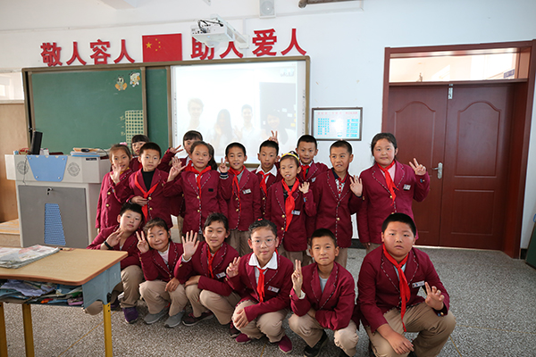

The live streams provided by Canadian foreign teachers open a window for children from poor families in remote villages to know about the real world, and thus improves their confidence in changing their lives.

‘After several classes, what impressed me most was that as long as I encountered problems in phonetic symbols, pronunciation, vocabulary and grammar in class, I was able to get correction right away from the foreign teachers. I was really happy!’ Yin Kaiqi, one of the pupils, told the reporter shyly.

While Jiang Hanyu, another pupil, said to the reporter. ‘I am confident to follow the course. I will study hard and give back to the good people who care about us so much in the future.’

‘Online English teaching enables children to communicate directly with foreign teachers, experience authentic English pronunciation and learn English in real situations. As the English teacher of the class, I learned the authentic English classroom instructions from the foreign teachers, and also found the lack of my own vocabulary, which prompted me to know how to remedy the shortfall, so as to better engage in teaching. Wu Xiaoxuan, an English teacher who volunteered to teach in this remote village, told reporters with a heavy feature.

**一堂跨越两大洲的英语课**

发布时间：2019-05-27 08:14:11    作者：    来源：[中国保险报网](http://www.zgbxb.com/)

□特约记者 李敬伟 摄影报道

Hello, everyone! Today we will talk about food from all over the world. First of all, let's review some vocabulary, then we will move on to show you some food from different countries and some videos.（大家好，今天我们要讨论一下全世界的美食。首先，我们复习一下单词，然后带你们看一下世界各地的美食，并播放几段视频。）

5月16日8时30分，在大连北部偏僻农村徐大屯中心小学三年级的课堂上，一堂连线加拿大雷克湖中学的实时空中英语口语教学正在进行，加拿大外教妮可儿（Nicole）、利亚姆（Liam）和布尔汗（Berhan）正在辅导中国偏远农村的孩子们“看图识字”。

同学们用略带方言的童音跟随外教们认真朗读，生怕漏掉任何一个单词。

“偏僻农村里的孩子知道这样的学习机会十分难得，也知道这可能就是他们未来摆脱家庭困境的希望。”太平养老大连分公司总经理王奎力告诉《中国保险报》特约记者。

一个小时的越洋空中英语同步教学很快结束了。记者应邀通过荧屏与远隔大洋的加拿大外教们进行视频连线对话。



“妮可儿、利亚姆、布尔汗，你们好！感谢你们携手太平养老的志愿者为中国农村孩子搭建英语空中课堂，你们在用实际行动参与中国扶贫攻坚这项有意义的工作的同时，也为中加两国少年儿童架起了一座友谊的桥梁！”

妮可儿爽快地说出她的感受：“我们参加这个项目，就是想帮助这些贫困家庭的孩子提高英语听说能力，重点教会他们用英语进行简单的对话，增强学习英语的兴趣。将来如果他们要去从事服务行业或者创业，英语能帮助他们迈向一个更高的平台。”

利亚姆接过妮可儿的话说：“我之所以喜欢这个项目，是因为可以借此与中国偏僻地区农村的孩子彼此了解沟通。虽然我们相隔这么遥远，但好像心却离得很近，在对话的时候，感觉他们就坐在我面前，跨越了空间，很温暖。”



徐大屯中心小学三年级只有一个班级，共有学生29名，其中单亲家庭、困难家庭和残疾同学占比达30%。2018年，太平养老在徐大屯村进行扶贫调研时，了解到徐大屯中心小学三年级这一特殊学生群体后，遂将扶贫工作重点聚焦于扶智即教育扶贫上。太平养老随后对徐大屯中心小学农村困难家庭孩子进行了一对一的帮助，帮助困难家庭的孩子一次性交付了每学年的校车费，给困难家庭的孩子免费投保了学平险。

2018年，了解到加拿大雷克湖中学“C²空中英语课堂”公益社团一直坚持在做四川南充山区石圭小学远程视频英语教学公益援助，太平养老与“C²空中英语课堂”公益社团取得联系，请求他们同时为徐大屯中心小学的贫困家庭孩子提供英语教学援助。这一跨洲的助学扶智项目很快获得雷克湖中学“C²空中英语课堂”公益社团的积极响应，并于2019年3月正式开课。为确保教学效果，太平养老还联系到大连外国语大学加拿大籍教师Rona参与徐大屯扶智项目，Rona又在大连外国语大学发起志愿者行动，组织大学生踊跃参与“C²空中英语课堂”支教扶智行动，由该校外语志愿者针对基础较差的学生进行针对性辅导，以此帮助学生跟上教学进度。



来自加拿大小外教原汁原味的远程视频英语教学，为偏僻农村贫困家庭的孩子打开了一扇通往世界的窗口，也由此提升了孩子们改变人生命运的自信心。

“上了几节课后，我感触最深的就是在课堂上遇到音标、发音、词汇、语法上拿不准的问题，马上就能得到外教老师及时纠正，真的很开心！”尹楷淇同学有些羞涩地跟记者吐露她的心里话。

姜函宇同学则面对记者朗声说：“我现在很有信心跟上课程。我一定努力学习，未来好回报关心我们的这些好人。”

“空中英语教学让孩子们能够直接和外教沟通，感受纯正的英语发音，学会在真实的情境当中进行英语学习。作为班级的英语教师，我跟外教学会了地道的英语课堂指令，同时发现了自身词汇量方面的不足，这也促使我们当老师的知道从哪里补短板，进而更好地投入教学当中。”自愿从城市来到偏僻农村教书的英语教师吴晓璇面色有些凝重地告诉记者。